WEAPON STATION Sniper W-25
PRODUCT OVERVIEW

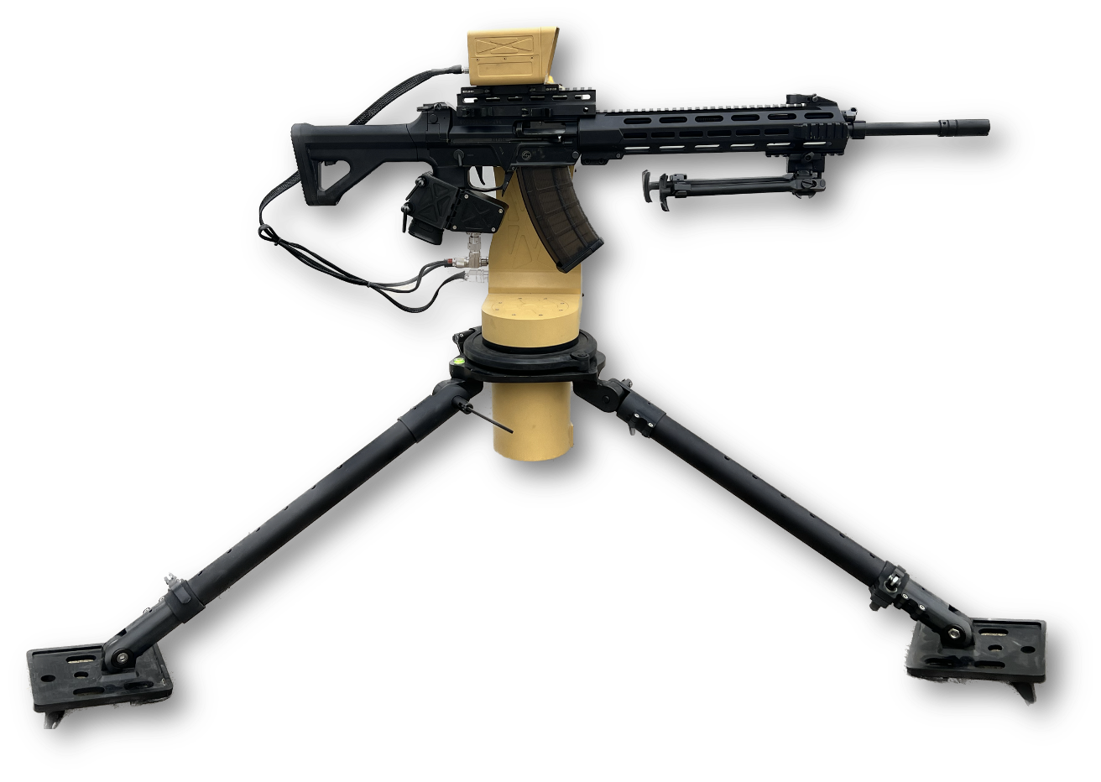

K-25 is a portable, ultralight remote weapon station designed for single-soldier carry and rapid random or fixed emplacement.It is primarily used by infantry squads to execute anti drone operations, infiltration, ambush, sniping, and guard control missions in urban, mountainous, and key-site combat environments, day or night.
It can be fixed and deployed using a tripod, and installed on fixed fortifications such as rooftops, windowsills, and walls; simultaneously, it can be mounted on light/small manned and unmanned vehicles. A dual-axis stabilization system is optional.
It can effectively neutralize or deter invading personnel targets and LSS UAV targets.
Equipped with a lightweight multi-sensor smart camera, it enables day/night reconnoiter through its color camera and infrared camera. The laser rangefinder provides precise target distance measurement.
Integrated with an intelligent fire control system. It enables automatic target acquisition, tracking, and aiming, thereby facilitating rapid, efficient, and precise target engagement. Simultaneously, it possesses intelligent capabilities including autonomous decision-making, continuous multi-target engagement, and coordination within multi-node, multi-asset combat networks..

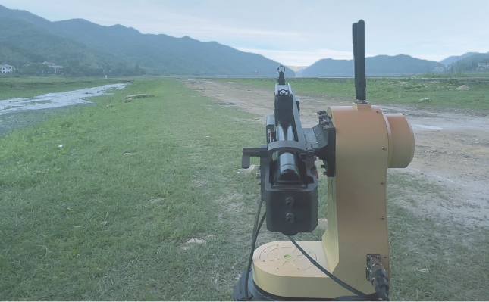
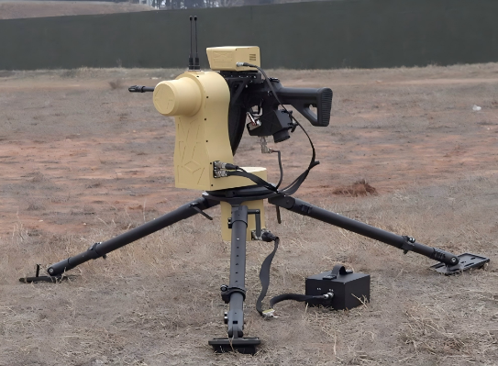
Application：

TECHNICAL SPECIFICATIONS

Parameter | Specification | Notes
Fit Guns and Ammunitions | 5.56mm NATO rifle  7.62*39mm rifle
Ammunition Capacity | 30 rounds | Depend on guns
Weight | ≤25kg | Without guns and ammunitions
Elevation | -20° to +45° | Depend on guns
Azimuth | N×360˚
Elevation slew rate | Max ≥45°/s, Min ≤0.03°/s
Azimuth slew rate | Max ≥60°/s, Min ≤0.03°/s
Maximum tracking rates | Azimuth ：Max ≥15°/s  Elevation：Max ≥15°/s
Power input | 30～52VDC
Power Consumption | 200W max
Operating Temperature | -20℃～+55℃
EO | 1920×1080 Pixels  30FPS  WFOV: 25˚×14˚  NFOV: 7.5˚×4.2˚
IR | 640×512 Pixels  30FPS  WFOV: 9˚×7˚
tracking distance | EO: drone target ≥480m  IR: drone target ≥350m | RCS=0.01cm2
Lidar ranging | EO: drone target ≥480m  IR: drone target ≥350m | RCS=0.01cm2
Counter-UAS Capability | ≥41.52% at 100m  Effective anti-UAVs: ～200m | DJI Phantom  Depends on the accuracy of the weapon

