WEAPON STATION Sniper W-150
PRODUCT OVERVIEW

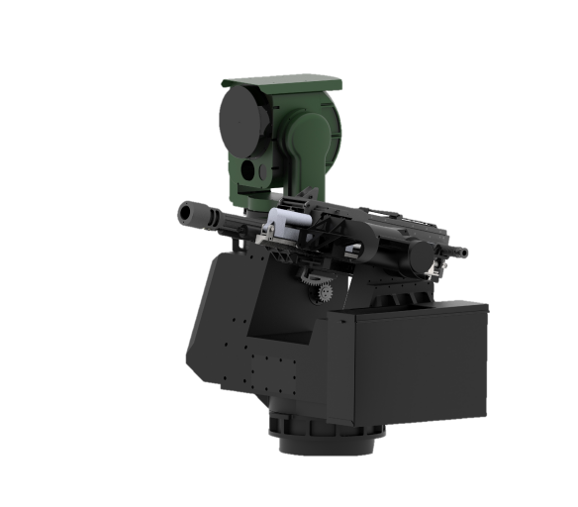

K-150 is a multi-platform, multi-role remote weapon station supporting multiple large-caliber weapons. It integrates automated detection, recognition, tracking, and precision strike capabilities against ground, surface, and low-speed aerial targets. Programmable ammunition enables effective engagement of concealed positions and LSS UAV targets.
- Multi-weapon reconfiguration
12.7mm Machine Gun
14.5mm Machine Gun
40mm Grenade Launcher
- Multi-platform deployment
Manned/Unmanned Surface Vessels
Light High-Mobility Vehicles
Light/Medium Unmanned Ground Chassis
Medium/Heavy Manned Armored Vehicles
Transport Vehicles, Self-Propelled Artillery.

Application
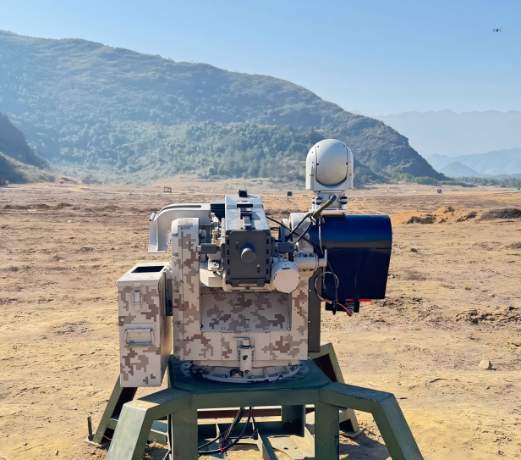

TECHNICAL SPECIFICATIONS

Parameter | Specification | Notes
Fit Guns and Ammunitions | 40mm grenade launcher  Airburst ammunition
Ammunition Capacity | 30～60 rounds | Depend on guns
Weight | ≤150kg | Without guns and ammunitions
Elevation | -20° to +45° | Depend on guns
Azimuth | N×360˚
Elevation slew rate | Max ≥45°/s, Min ≤0.03°/s
Azimuth slew rate | Max ≥60°/s, Min ≤0.03°/s
Maximum tracking rates | Azimuth ：Max ≥15°/s  Elevation：Max ≥15°/s
Power input | 26±4VDC
Power Consumption | 2000W max
Operating Temperature | -20℃～+55℃
EO | 1920×1080 Pixels  30FPS  WFOV: 61.9˚×37.4˚  NFOV: 2.3˚×1.3˚
IR | 640×512 Pixels  30FPS  WFOV: 9˚×7˚
tracking distance | EO: drone target ≥1000m  IR: drone target ≥350m | RCS=0.01cm2
Lidar ranging | EO: drone target ≥800m  IR: drone target ≥350m | RCS=0.01cm2
Counter-UAS Capability | ≥50% at 250m  Effective anti-UAVs: ～500m | DJI Phantom  Depends on the accuracy of the weapon

