Smart Elderly Care Monitoring System
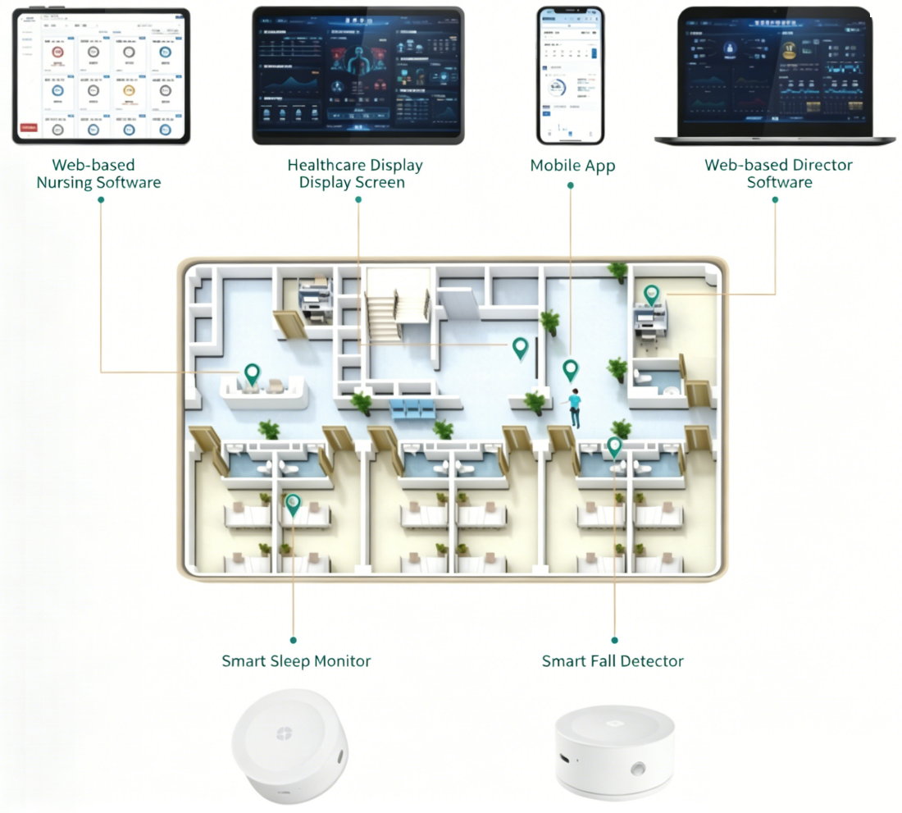

The Smart Elderly Care Monitoring System utilizes sensors such as the intelligent fall detector and intelligent sleep monitor to detect, collect and analyze body movement and vital sign data of the elderly under care in real time. Data is uploaded to the cloud data center via WIFI or 4G for reception, parsing, analysis and storage.
By comprehensively applying big data, artificial intelligence and other technologies, the system’s intelligent algorithms analyze and process the data. When an alarm event is identified, notifications and alerts are displayed through the mobile mini-program or web-based software to inform caregivers, providing the elderly with 7/24 intelligent, humanized and uninterrupted protection.

Features
