Runway light type FOD detection Radar
PRODUCT OVERVIEW
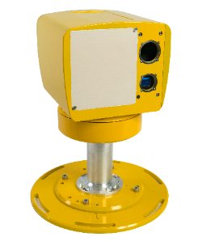
The system is deployed on both sides of the airport runway. The system integrates millimeter wave FOD radar and HD camera sensors, allowing real-time detection of different types of FOD on the runway.
TECHNICAL SPECIFICATIONS
Specifications | Parameters
Max detection range | ≥70m
Min FOD detectable size | 2cm
Locating accuracy | ≤1m
Runway scanning time | ≤30s
Real target probability | ≥99%
Real target working time | ≥8h
Coverage, azimuth | 0°-180°
Weight | ≤15kg
Power supply | 24VDC
Power consumption | ≤100W
Output interface | Ethernet port（TCP/IP）
Application:
