Radar Thunder X-14
Product Overview
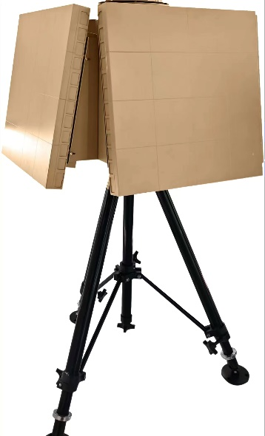
The X-band radar for detecting low, slow, and small (LSS) targets adopts a 2D phased array architecture with a modular sub-array design, enabling flexible array surface expansion to meet the needs of various operational scenarios.
This radar features long detection range, high target tracking update rate, and excellent range resolution. It supports single, dual, or quad-array configurations and can be deployed in both fixed and mobile platforms, offering versatile modes to accommodate different integration requirements.
It can be widely applied to key core area protection work such as border defense, security and airports.

TECHNICAL SPECIFICATIONS
Specification | Parameter
Band | X
Detection Range | >14km（RCS=0.01㎡，DJI Phantom drone）
Coverage | Four sided array azimuth 360 °,  single array azimuth ± 45 °
Target Capacity | >1000 Targets
Dimensions | single array≤0.6x0.6x0.15m  Four sided array≤0.8x0.8x0.8m

