Radar Thunder X-10

PRODUCT OVERVIEW
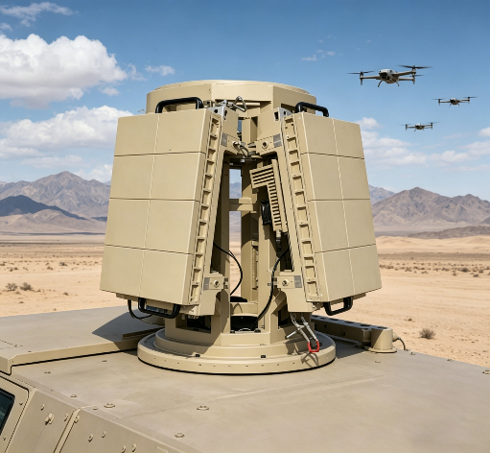
The 10km Phased Array Low-Altitude Small Target Detection Radar, model Thunder X-10, is an advanced all-solid-state, fully digital radar system engineered specifically for detecting low-altitude, slow-speed, and small-sized (LSS) targets.
Adopting a four-faced two-dimensional phased array configuration and leveraging the micro doppler operating principle, this radar integrates cutting-edge technologies such as clutter suppression, target tracking, and intelligent recognition algorithms.
It enables round-the-clock, all-weather, and full-airspace detection, tracking, and classification of various LSS targets, including multi-rotor UAVs, fixed-wing UAVs, and birds.
Designed to adapt to two core deployment scenarios – fixed installation and vehicle-mounted mobile deployment – this radar offers versatile application capabilities.
It can provide long-term fixed security surveillance for critical locations and key security areas, while also being mountable on various mobile platforms to fulfill on-the-go detection and temporary defense tasks.
With a highly integrated and modular design, the radar supports quick disassembly, rapid deployment, and easy replacement, allowing it to flexibly meet the requirements of different installation environments and mission objectives.

TECHNICAL SPECIFICATIONS
System Attribute | Parameter
Frequency | X-band with Micro Doppler
Target Detection | ≥ 10Km (RCS:0.01m²) (Ex: DJI PHANTOM 4)
Azimuth Coverage | 360°
Elevation Coverage | 0-90°
Velocity Coverage | 0.5m/s-100m/s
Simultaneous Tracking | ≥ 40 Targets (continuous and automatic)
Data Rate | Search: 5s, Tracking: 0.5s
Accuracy | Range:10m, Azimuth: 0.3°, Elevation: 0.3°
Blind Zone | 150m
Weight | 125kg
Power Supply | 24V/220V
Power Consumption | 3500W
Dimensions | 600x315x113mm (Single array)
Protection Standard | IP65 (Certified by Manufacturer)
Frequency Compliance | Comply with Electromagnetic Compatibility (EMC) and Electromagnetic Interference (EMI) (Certified by Manufacturer)
Operating Temperature | -40℃~60℃

