Intelligent Sleep Monitoring Radar

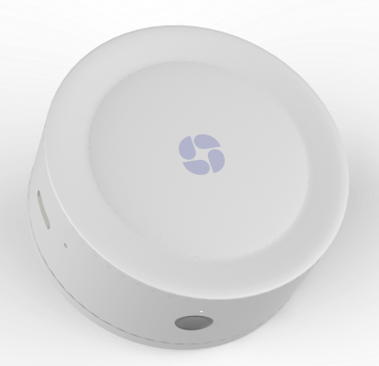
PRODUCT OVERVIEW
The Intelligent Sleep Monitoring Radar is an intelligent vital signs monitoring system based on millimeter-wave radar technology.It uses non-contact methods to monitor indoor vital signs(including respiratory rate,heart rate,etc.)and sleep quality.The product is equipped with a mobile app,allowing guardians to monitor their family’s situation at any time.In case of abnormal vital signs or sudden death,the Radar can automatically dial emergency calls,notifying guardians for timely intervention.Itcan also be usedfordaily sleepquality monitoring,helping to detect and prevent issues like sleep apnea and other sleep disorders.
Features
- High Precision: Vital sign detection accuracy ±1/min (sleep state)
- Wide Coverage: Vital sign detection distance of 1.5m, body movement detection distance of 5.5m, body movement coverage of 20㎡
- Multi-function: Presence detection, respiration monitoring, heart rate monitoring, sleep quality monitoring, voice alarm, etc.
- Contact-free: Non-intrusive detection, no wearable Radars required, no changes to daily habits needed
- Privacy-Protected: Non-optical camera detection, suitable for bedrooms
- Easy to Use: 5-minute side installation and commissioning, WIFI/4G optional
- Enhanced Safety: Supports telephone alarms and mini-program reminders on mobile phones
- Report Generation: Automatically generates daily monitoring reports for easy access to health data
Application:
