Intelligent Fall Detection Radar

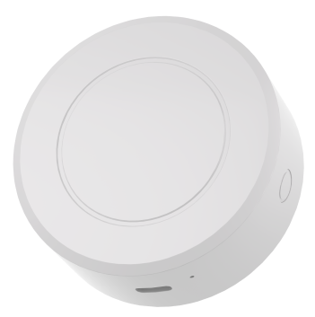
PRODUCT OVERVIEW

The Intelligent Fall Detection Radar is an intelligent human detection system based onmillimeter-wave radar technology. It employs non-contact methods to achieve precise indoor humansensing (fall prevention alert, long-duration presence alert, etc.). The product is equipped with amobile app, allowing guardians to monitor their family's situation at any time. In the event ofa fall, the device can automatically dial emergency calls, notifying the guardian to provide timely assistance.
Features
- High Precision: 99% accuracy in fall detection
- Wide Coverage: Detection area of 24 ㎡, field of view angle of 120°
- Multi-function: Activity tracking, vitality monitoring, fall alarm, long-stay alarm, etc.
- Contact-free: Non-intrusive detection, no wearable devices required, no changes to daily habits needed
- Privacy-Protected: Non-optical camera detection, suitable for bedrooms and bathrooms
- Easy to Use: 5-minute ceiling installation and commissioning, WIFI/4G optional
- Enhanced Safety: Supports phone call alerts and mini-program notifications

Application:
