Anti-UAV Defense System
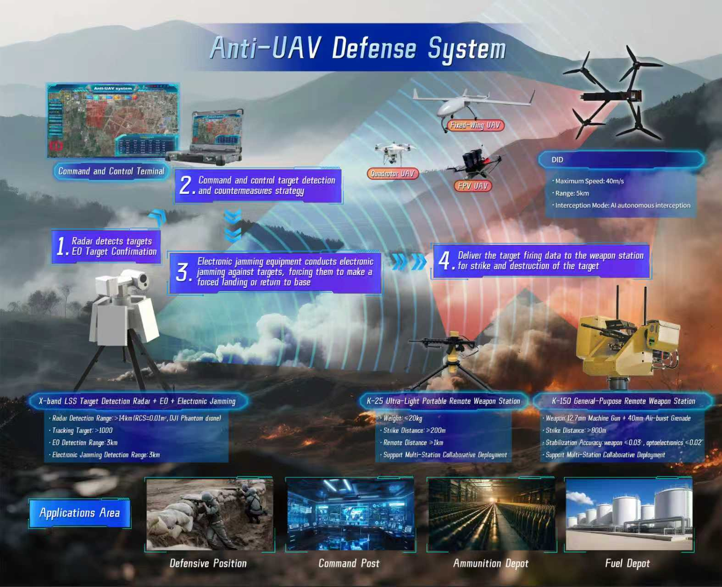
SYSTEM OVERVIEW

The anti-UAV defense system adopts an integrated architecture, comprising a detection subsystem, a countermeasure subsystem, and command control software. The detection subsystem employs multi-sensor technologies (radar, electro-optical devices, etc.) to achieve all-weather, omnidirectional detection, search, and tracking of low-altitude UAVs, automatically acquiring target parameters (range, azimuth, altitude, velocity, etc.). The countermeasure subsystem integrates soft/hard kill means (electronic jamming, weapon stations, DID, etc.) to neutralize threats. Command control software visualizes comprehensive situational awareness, assists in formulating defense strategies, and automatically guides directional jamming devices, weapon stations and DID to repel or intercept the targets.
It can be widely applied to the protection of key core targets such as position command posts, oil depots, ammunition depots, government security sites, airports, and energy infrastructure.
TECHNICAL SPECIFICATIONS
Specifications |  | Parameters
Radar | Band | X
Radar | Operation Distance | >14km(RCS=0.01㎡,DJI Phantom 4 Drone
Radar | Coverage Range | Single array: azimuth ±45°  Quadruple arrays: azimuth 360°
Radar | Tracking Target | >1000
Infrared Thermal Imaging Equipment | Detector | Uncooled VOx IR FPA
Infrared Thermal Imaging Equipment | Detection Range | 3km
Infrared Thermal Imaging Equipment | Resolution | 640×512
Infrared Thermal Imaging Equipment | Lens Focal Length | 38～190mmContinuous Zoom Lens
High-Definition Visible Light Equipment | Sensor | 1/1.8" Target Starlight-Level CMOS with ICR Color-to-Black Function
High-Definition Visible Light Equipment | Detection Range | 3km
High-Definition Visible Light Equipment | Resolution | 1920×1080
High-Definition Visible Light Equipment | Focal Length | 11～860mm  High-Definition Motorized Zoom Lens
Directional Jamming Equipment | Effective Jamming Distance | ≥3km
Directional Jamming Equipment | Jamming Coverage Area | Azimuth∶0°～360°; Pitch∶30° ～90°
Directional Jamming Equipment | Jamming Frequency Band | 900M/1.6G/2.4G/5.8G
Weapon Station | Range | 200m（W-25）  800m（W-150）
Weapon Station | Hit Probability | The hit rate of 1 hit in 3 attempts is ≥ 90% (W-25).  The knockdown rate within 10 seconds is ≥ 60% (W-150).  The knockdown rate within 30 seconds is ≥ 90% (W-150).
DID |  | Maximum Speed: 40m/s  Range: 5km  Interception Mode: AI autonomous interception
Dimensions |  | Detection section: 100×100×170 cm (L×W×H)  Countermeasure section: 1170×970×900 cm (L×Wh×H)
Weight |  | Detection section: 240 kg  Countermeasure section: 20 kg / 250 kg
Power Supply |  | AC 220V

