Airport Bird Detection and Counter-UAV Integrated System

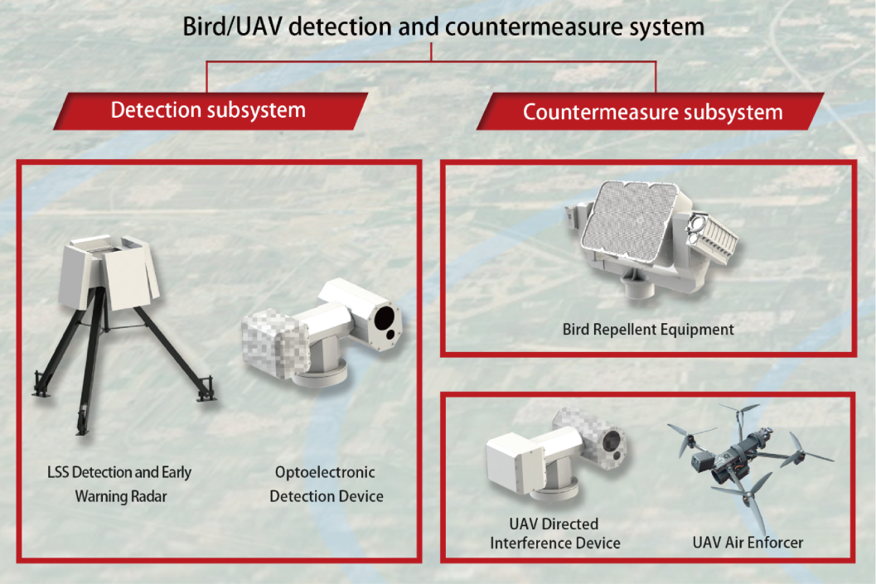
SYSTEM OVERVIEW
Leveraging its radar technology expertise, the company has developed an integrated system combining radar detection, electro-optical identification, and comprehensive control management. This system is primarily designed to detect, deter, and manage bird activities and unauthorized drones in airport environments.
Our integrated bird detection and counter-UAV system has been successfully deployed at major airports, including Beijing Daxing International Airport and Chengdu Tianfu International Airport, where it has demonstrated excellent performance.
TECHNICAL SPECIFICATIONS
Specification | Parameter
Frequency Range | X bands
Detection Range | ≥12km（RCS=0.01㎡，DJI Phantom 4 drones or pigeon swarm)
Coverage Area | Single array face ±45° azimuth  Four array faces 360° azimuth
Simultaneous Tracking Capacity | ≥1000 targets

